**Android Project Setup Instruction**

**For**

**Plant Diagnosis System**

# **Android Setup: Install Android Studio**

1. Download and install from: <https://developer.android.com/studio>

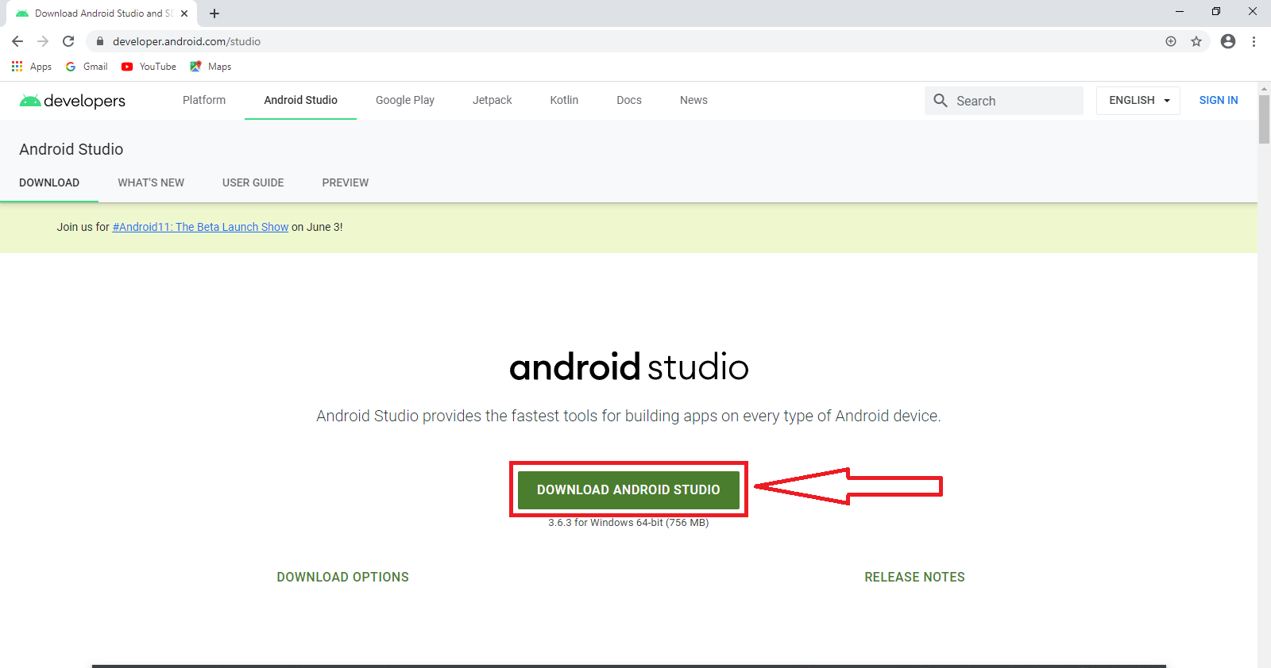

1. Start Android Studio, and go through the ‘**Android Studio Setup Wizard**’.

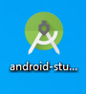

1. This installs the latest Android SDK, Android SDK Command-line Tools, and Android SDK Build-Tools, which are required by Flutter when developing for Android.
2. Open the **Android Studio SDK Manager**

# **Set up Android Device:**

To run and test Flutter app on an Android device, It needs an Android device running **Android 4.1** (API level 16) or higher.

1. Enable **Developer options:**  go to **“Settings > About Phone”**

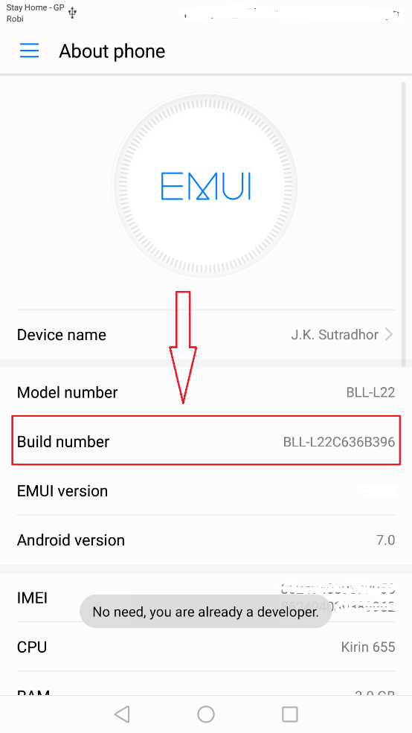

1. Tap 5-7 times continues on **‘Build Number’** (It will enable developer option for Project Run)
2. After tapping, it will show a toast **‘You are in developer mode’**.  
   If you did this already, you will get the toast **‘No need, you are already a developer’** .
3. Again, Go to “**Settings > Developer Option”**
4. Enable **USB debugging** on your device. Tap on the **‘USB debugging’** to enable it.
5. And If the alert dialogue is opened then simply click on the marked ‘OK’ button

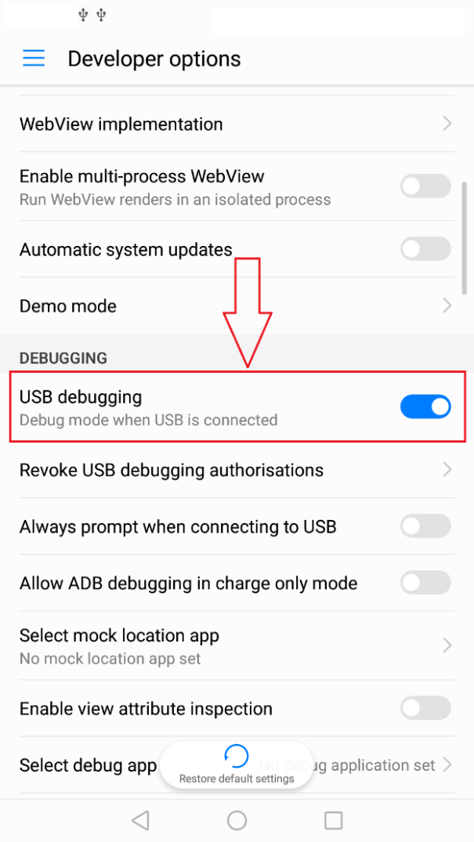

1. Using an USB cable, plug the phone into the computer. If prompted on the device, authorize the computer to access that device by click on the marked ‘OK’ button.

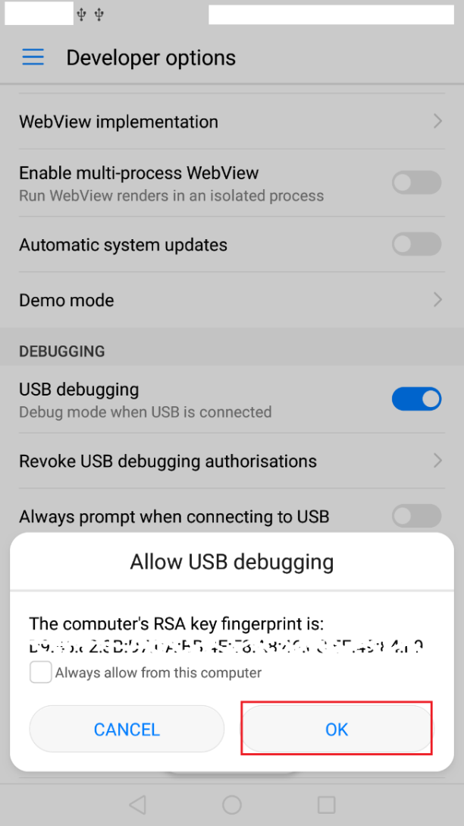

**Windows-only,** Install the[**Google USB Driver**](https://developer.android.com/studio/run/win-usb) if it fails to detect automatically. Help guide is available in- <https://developer.android.com/studio/run/win-usb>

# **Set up the Android Emulator:**

To prepare to run and test Flutter app on the Android emulator, follow these steps:

* Enable [VM acceleration](https://developer.android.com/studio/run/emulator-acceleration) on your machine.

1. Start Android Emulator.
2. Click on the marked Icon as below image



1. Click on the **Create Virtual Device**

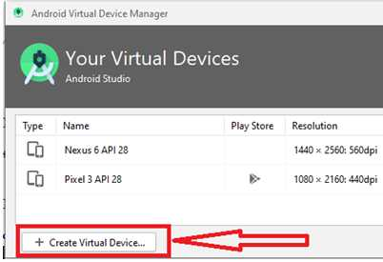

Or, Launch **Android Studio > Tools > Android > AVD Manager** and select “**Create Virtual Device”**. (The **Android** submenu is only present when inside an Android project.)

1. Choose a device definition and select **Next**.

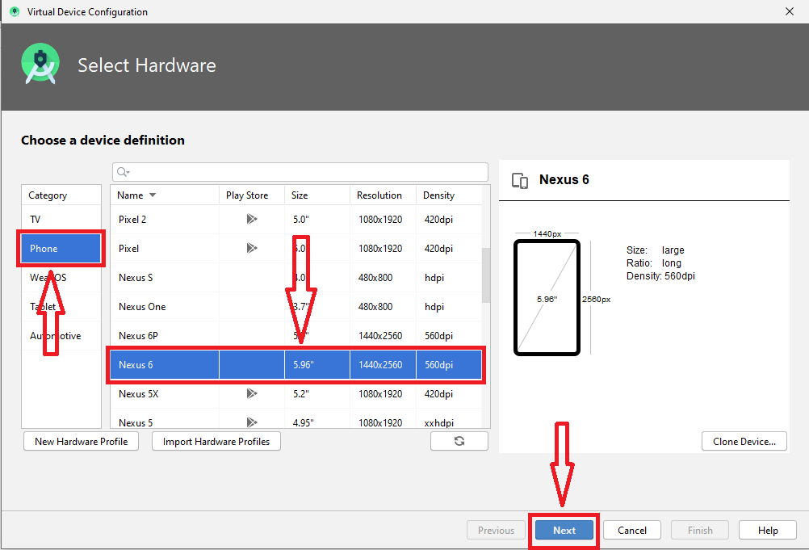

1. Select one or more system images for the Android versions, and select **Next**. An *x86* or *x86_64* image is recommended.

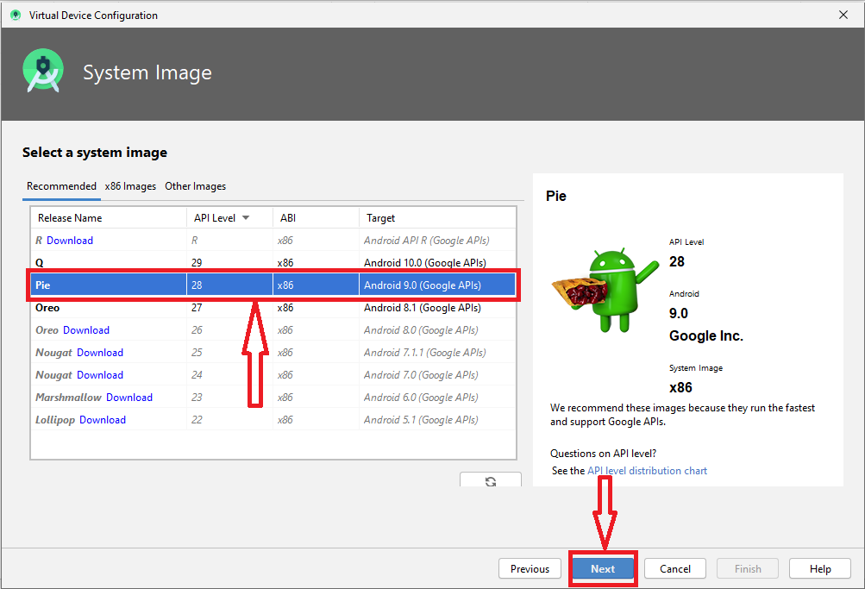

1. Under Emulated Performance, select **Hardware - GLES 2.0**. Verify the AVD configuration is correct, and select **Finish**.

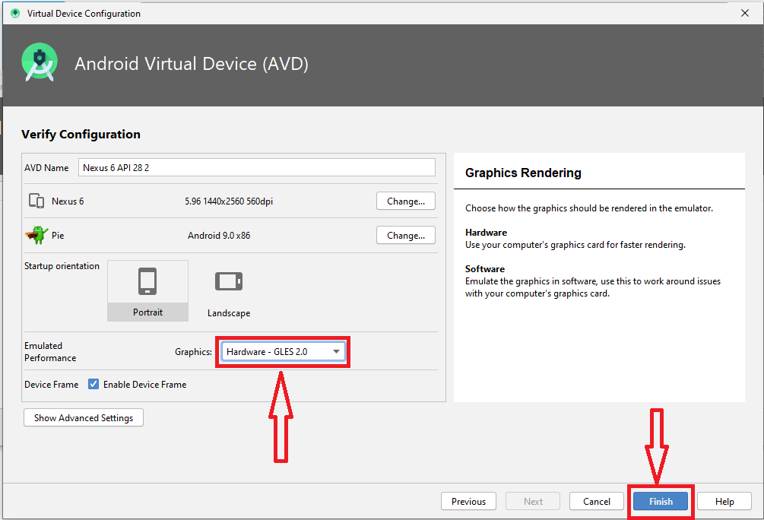

1. In Android Virtual Device Manager, click **Run** from the toolbar.

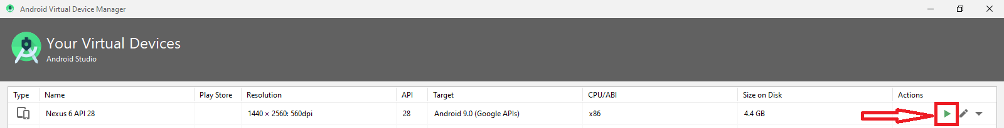

1. The emulator starts up and displays the default canvas for selected OS version and device.

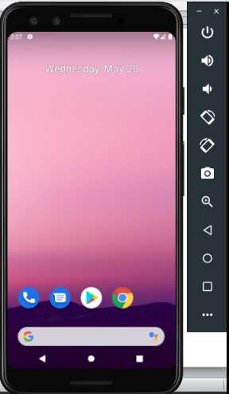

# **Running Project in the Emulator:**

1. Check out the project from Git.
2. Open the project in android studio marked menu.
3. 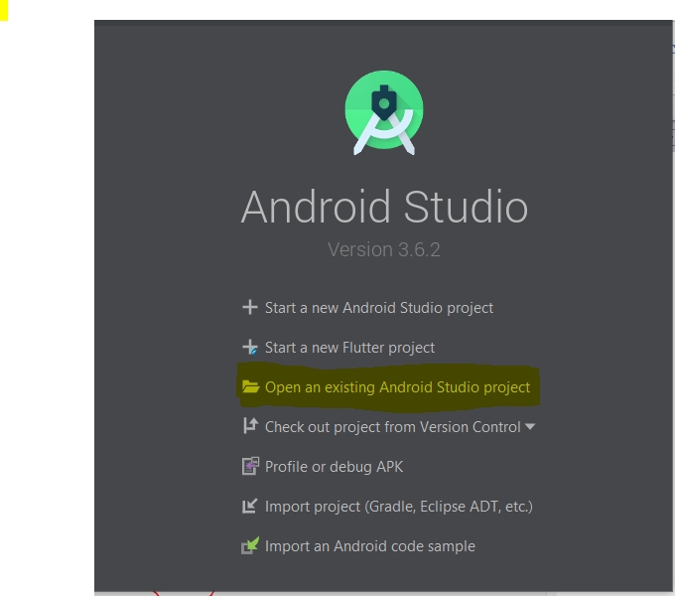
4. Select the project folder which is downloaded from Git repository.
5. Then, click on the **run icon**  to run the project in the device/emulator (show in the image given below).



1. Then the project will successfully run in the Emulator/device which is selected from this dropdown



